**FLEET UPDATES VERSION 4.9.8**

**Note: Sample lang ang mga data sa screenshots.**

# Notifications menu.



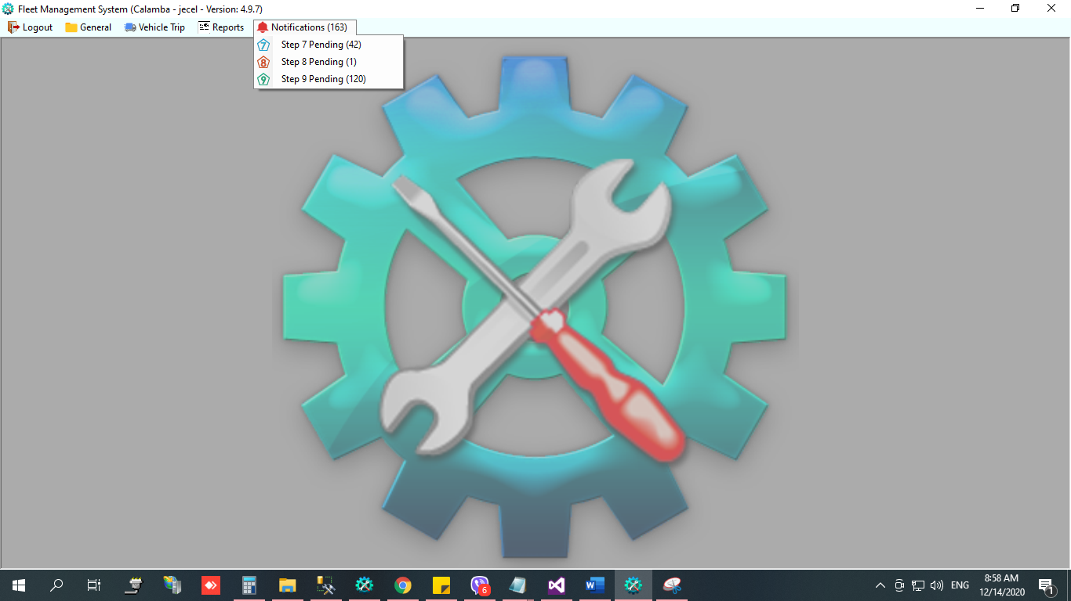

# Notifications - Step 9 Pending

* Per Trip

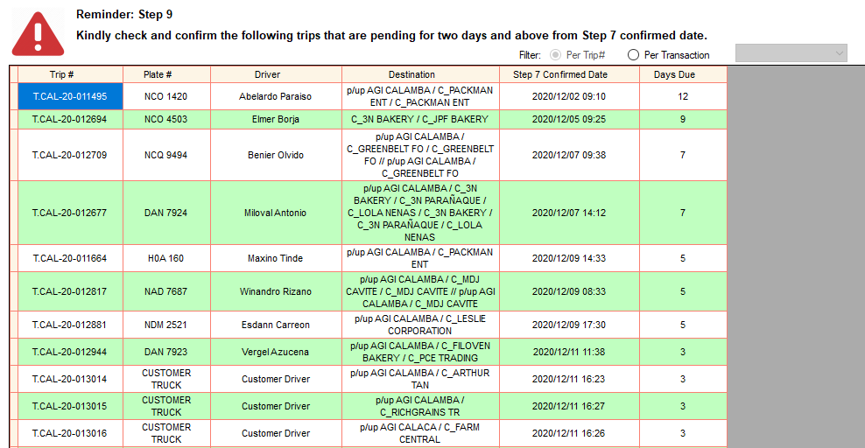

* 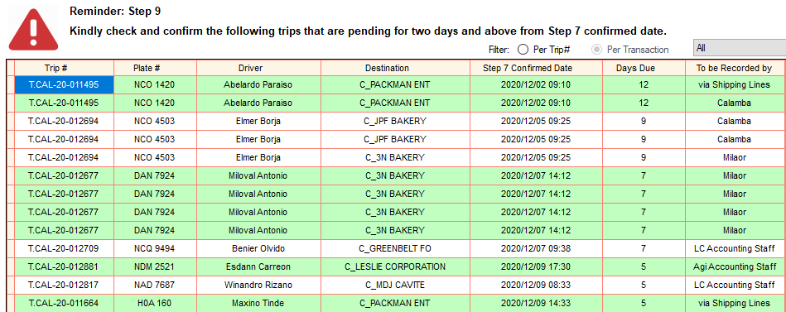Per Transaction

# Create order.

* 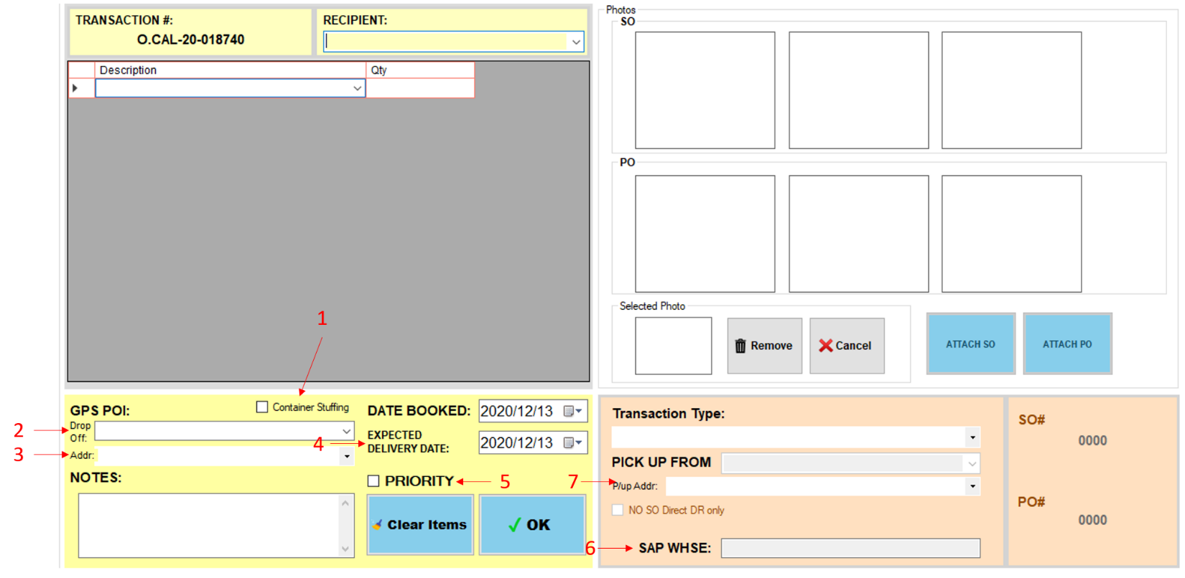Additional fields

1. Container Stuffing – check if for stuffing only (delivery via shipping lines)
2. Drop-off – GPS POI name kung saan dadalhin ang items. Kung bago ang customer/location at walang POI until madeliveran, select “---TEMPORARY POI---”. Hindi ma ko-close ang Step 9 hanggat hindi na a-update ng Logistics Staff ang final GPS POI name.
3. Drop-off address – GPS POI address
4. Expected Delivery Date – date kung kailan dapat madeliver
5. Priority – check if priority
6. SAP Whse – automatic if connected in sap
7. Pick up address – supplier warehouse GPS POI address

* If connected sa SAP
* No need to attach SO / PO / ITR file
* If SALES TRANSACTION, automatic na ang mga

1. Recipient – SAP Customer code, not editable
2. Items and quantity – still editable in case of partial delivery
3. SAP Whse – not editable
4. Date Booked – SAP Document date, editable
5. Expected Delivery Date – SAP Delivery date, editable

* If STOCK TRANSFER, automatic na ang mga

1. Items and quantity – still editable in case of partial delivery
2. SAP Whse – not editable
3. Date Booked – SAP Document date, editable
4. Expected Delivery Date – SAP Delivery date, editable

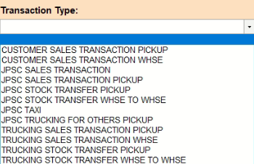

* New Transaction types

1. 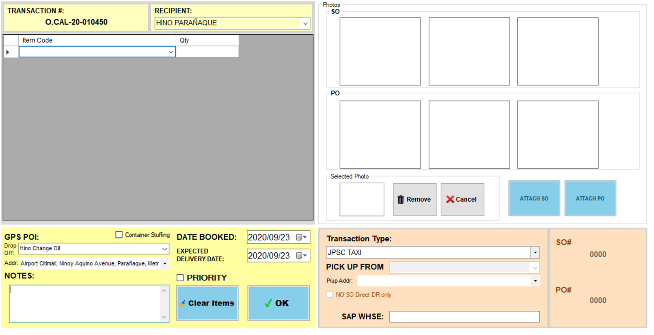JPSC TAXI – need na gawan ng create order kapag taxi. No reference numbers and no items. See [Trip Scheduling. (TAXI)](#_Trip_Scheduling._(TAXI))
2. JPSC TRUCKING FOR OTHERS PICKUP – Need ng SO#. ito ang transaction type kapag ang JPSC truck ay gagamitin para mag deliver sa customers ni AGI / Oro Allado (TRUCKING ONLY FOR AGI CUSTOMERS / TRUCKING ONLY FOR ORO ALLADO CUSTOMERS)

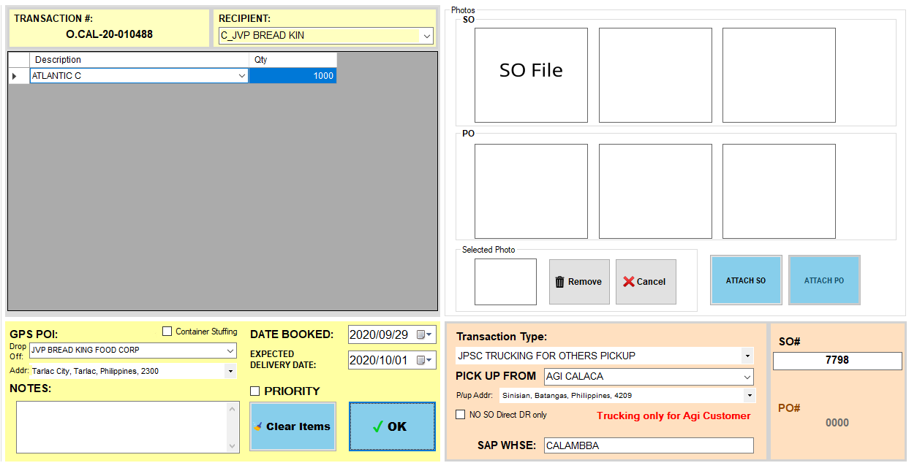

* STOCK TRANSFER PICKUP FRM need ng PO# / ITR#
* If pickup from supplier warehouse (Ex. Pup AGI Calaca, deliver ang stocks sa customer)
* Before ang ginagawa sa fleet, ang create order is **pup AGI Calaca deliver to customer**. Tapos pag dating ng step 7 nireresched na lang dahil uuwe yung truck sa calamba for resibo / diesel / allowance dahil ibang trip naman ang deliver pa customer.
* Ngayon, kung alam na uuwe ang truck galing sa pag pick up, para kumuha ng resibo / diesel / allowance, ang create na sa fleet is **pup AGI Calaca STOCK TRANSFER pa Calamba**, hindi irereschedule sa step 7, attach DN at mag note lang na hindi nag unload divert sa customer. Need ito gawin dahil sa GPS POI.
* Kapag naka ‘TO FOLLOW’ ang reference#, need mag lagay ng reason bakit.

# Edit created order.

1. In Order Transactions module, right click the transaction# you want to edit.
2. 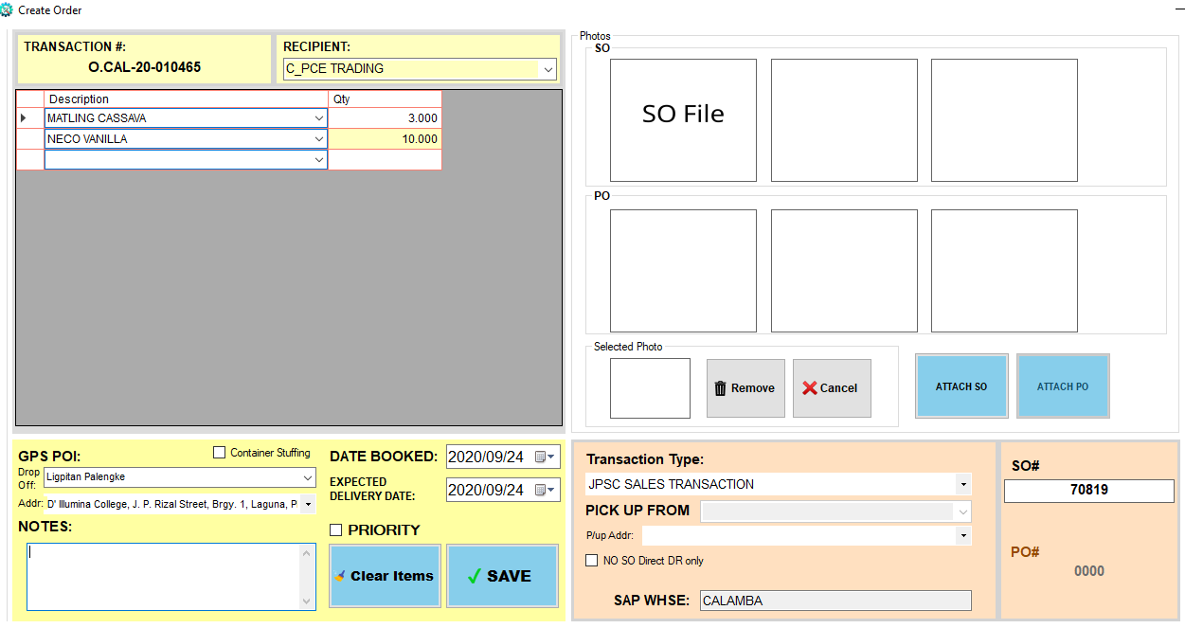Then, select Edit Orders.
3. Edit details.
4. Then, click SAVE button.
5. Pag na edit ang order details, makikita na may red icon sa tabi ng transaction#.
6. 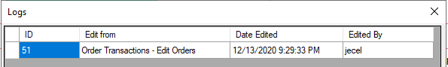To view the date and time edited and kung sino nag edit, right click the transaction#, then, select View Edit Logs.

Note: pag na add na ang transaction sa trip, hindi na pwede i-edit ang transaction type.

# Cancel created order



1. In Order Transactions module, right click the transaction# you want to cancel.

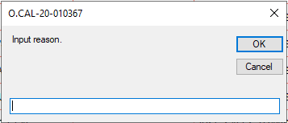

1. Input reason why do you want to cancel the order.
2. Then, click OK button.

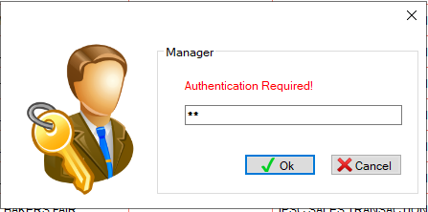

1. Authentication required. Input password.
2. Then, click OK button.

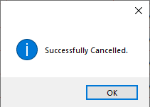



# Trip Scheduling.

* 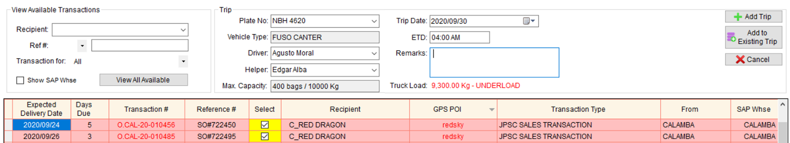Truck load
* Pag nag select ng transactions, nako-compute kung under load or over load.
* Steady items
* pwede na kahit hindi naka pick up from ang create order

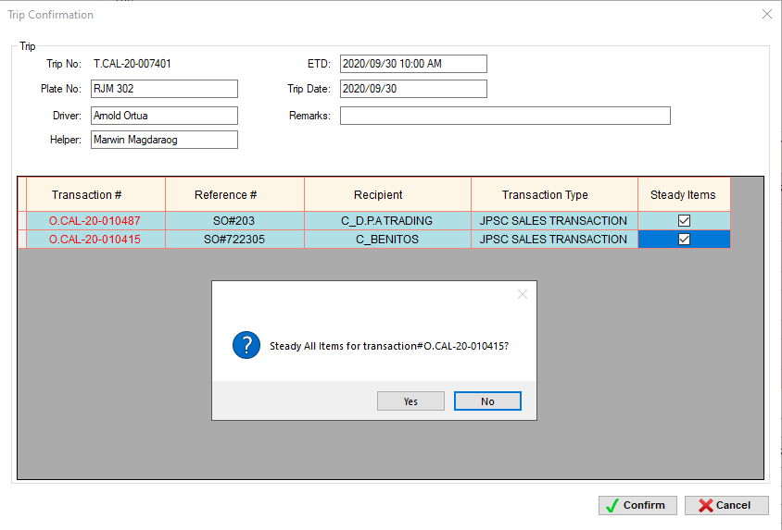

* Naayos na ang error na INVALID PLATE# pag nag add to existing ng transaction sa CUSTOMER TRUCK.
* Customer truck pick up
* 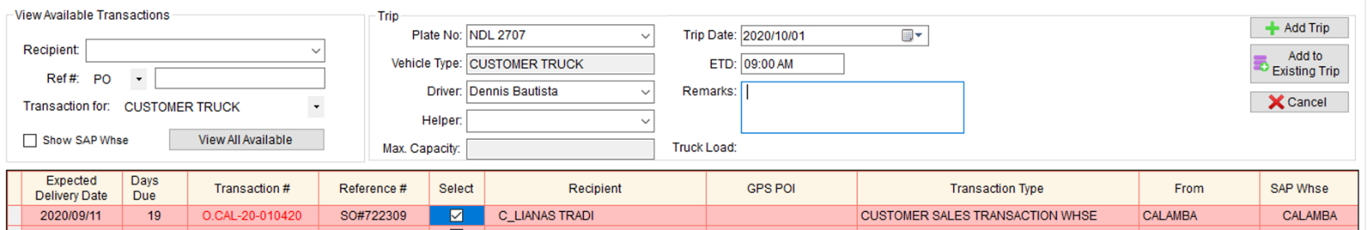Need na ipa add ang plate# at driver name ng customer truck na mag pipick up
* Hindi makakapag schedule kung hindi pa naka Good Condition sa Motorpool inspection.

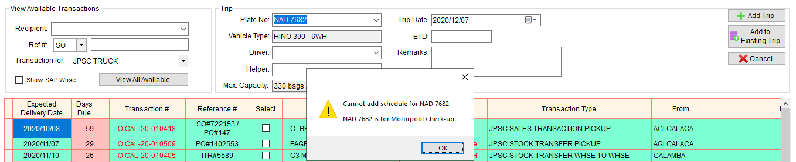

# Trip Scheduling. (TAXI)

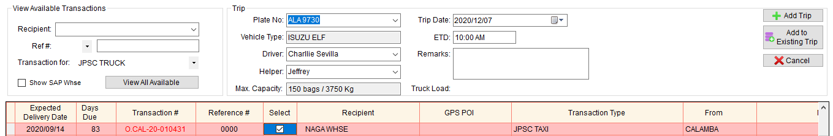

1. Input Trip information
2. Select transaction na may transaction type na JPSC TAXI
3. Then, click Add Trip

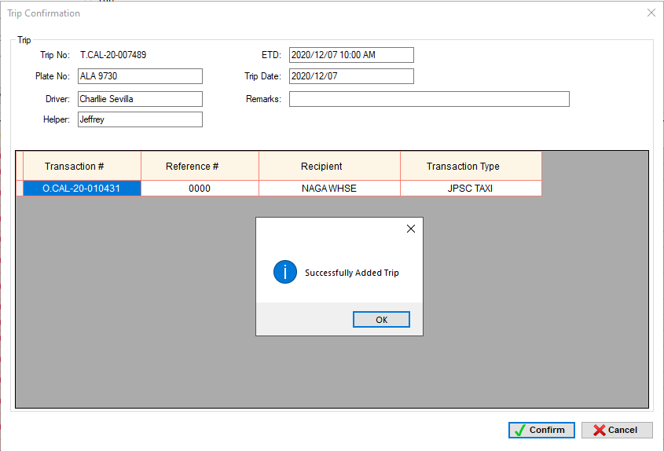

1. Click Confirm button.

# Trip Dispatching. (Step 1)

* Nilipat na sa Step 1 ang pag iinput ng Actual Diesel beginning

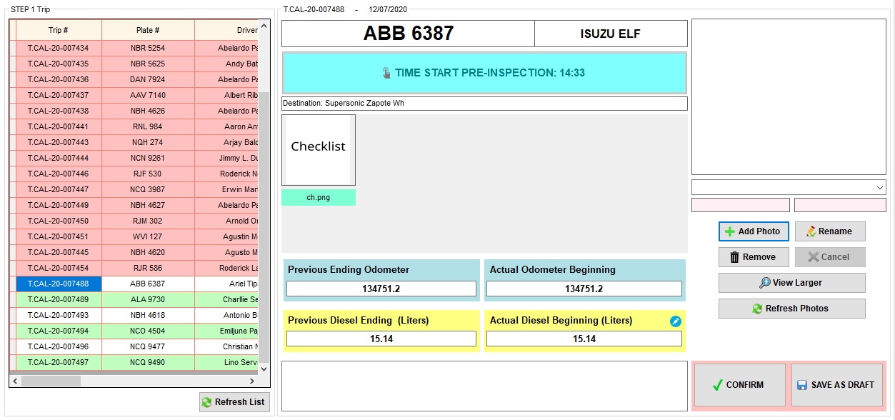

* Input inches in Actual Diesel Beg (Liters)

Stick na ginagamit panukat ng diesel sa mga truck

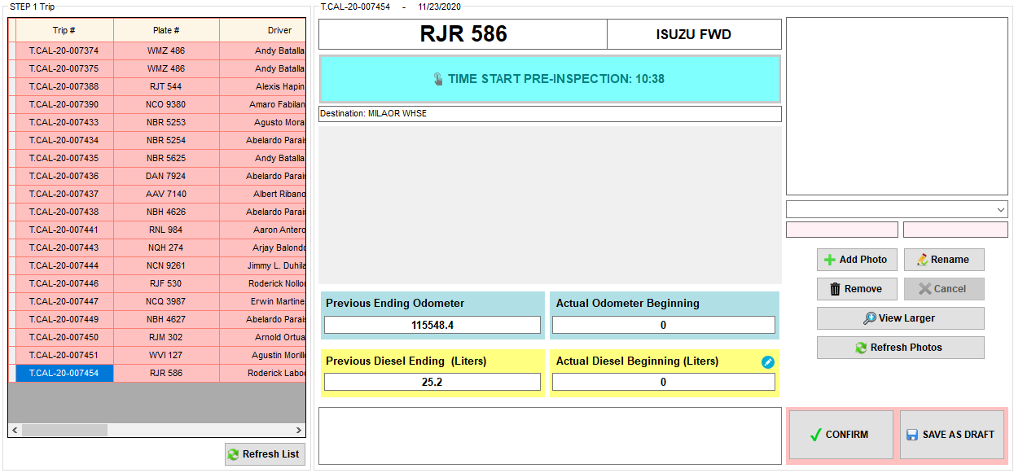

Click this icon to view the converter.

1. Click the icon beside the Actual Diesel Beginning (Liters).

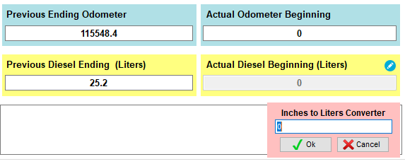

1. Input the diesel in Inches.

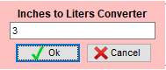

1. Click Ok button to convert.

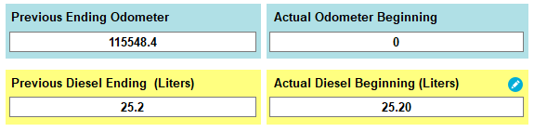

**Inches to Liters Conversion**

Plate#: **RJR 586**

Liter per Inch: **8.4**

Diesel measurement in Inches: **3.0**

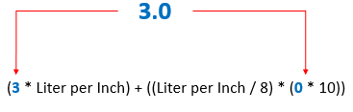

= (3 * 8.4) + ((8.4 / 8) * (0 * 10)

= (25.2) + (1.05 * 0)

= 25.2 + 0

= 25.2

Actual Diesel Beg (Liters) = **25.20 Liters**

# Trip Dispatching. (Step 2)

* Since nasa Step 1 na ang pag iinput ng Diesel beginning, nag sho-show lang dito ang na input sa Step 1.
* Hindi makaka attach ng PO for diesel kung hindi pa confirm ang Step 1.
* Hindi rin mako-confirm ang Step 2 kung hindi pa close ang Step 1.
* 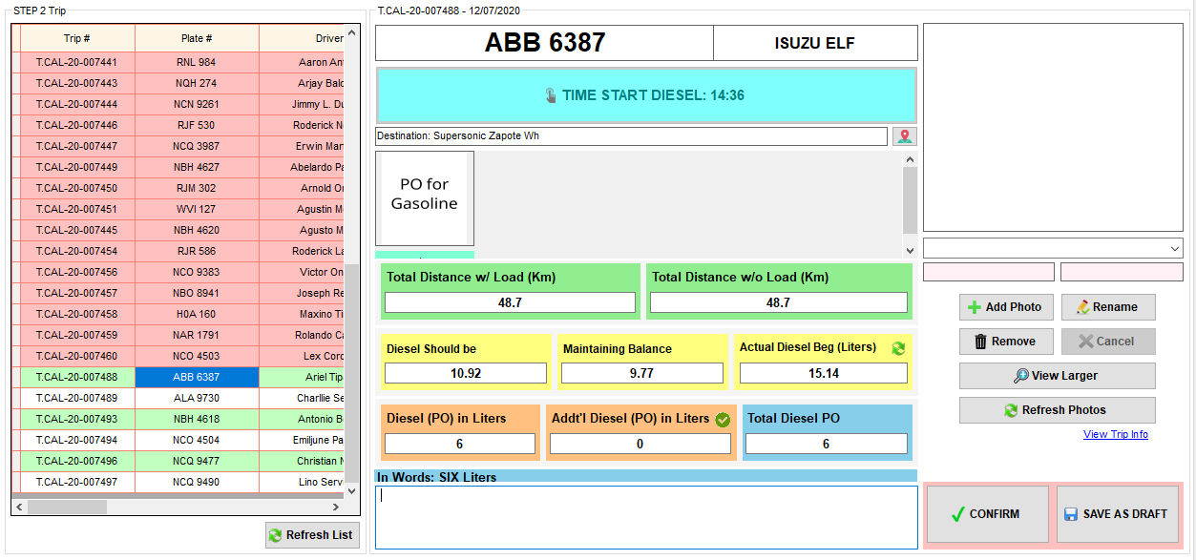Mayroon na ring naka lagay na *In Words* para sa Total Diesel PO.
* Computation ng Distance
* Since sa create order mase-set na ang GPS POI kung saan pupunta ang truck, maaring ma compute na automatically ang distance nito kung na set na sa database ang standard distance.
* Distance Computation if One Drop off
* Applicable only if the drop off point has a standard distance.

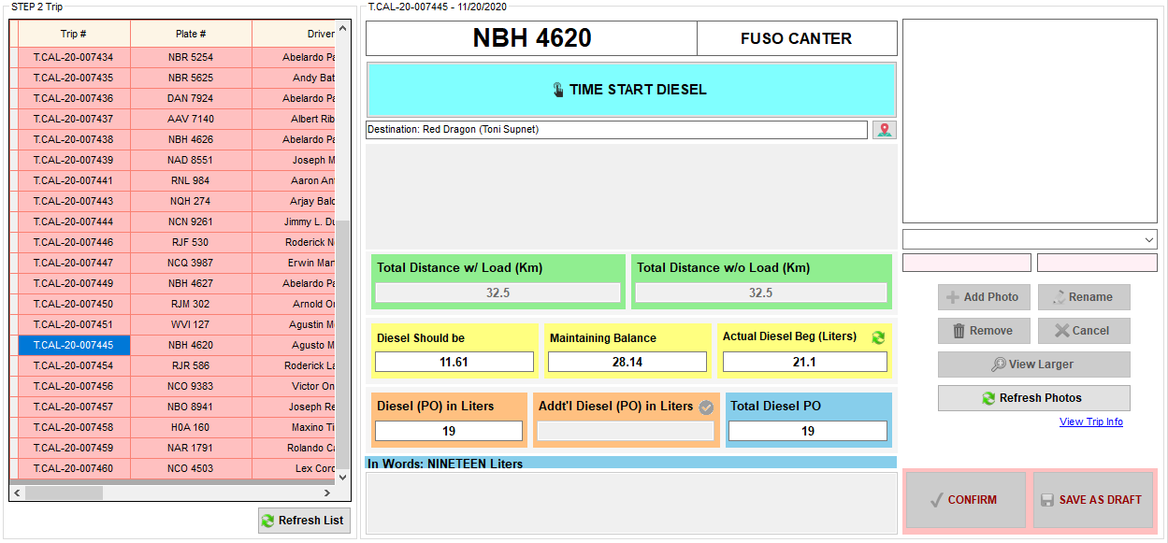

Click this button to view the standard distance

* 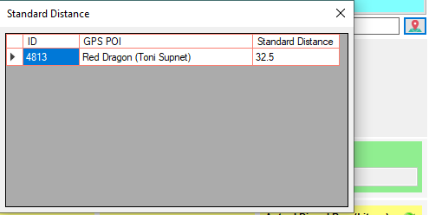To check if the standard distance is already set in the database, click the GPS POI button beside the destination label.

1. Select trip# or plate#.
2. If the trip has one drop off point only, even the step is not yet started, Total Distance w/ Load (Km) and Total Distance w/o Load (Km) are automatically computed if the standard distance is already set in the database.
3. Click TIME START DIESEL.
4. Total Distance w/ Load (Km) and Total Distance w/o Load (Km) are still editable.

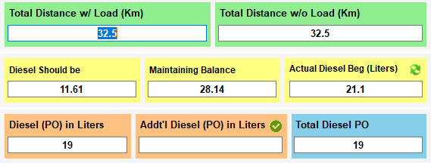

* Distance Computation if Multiple Drop off
* Applicable only if all the drop off points have a standard distance.

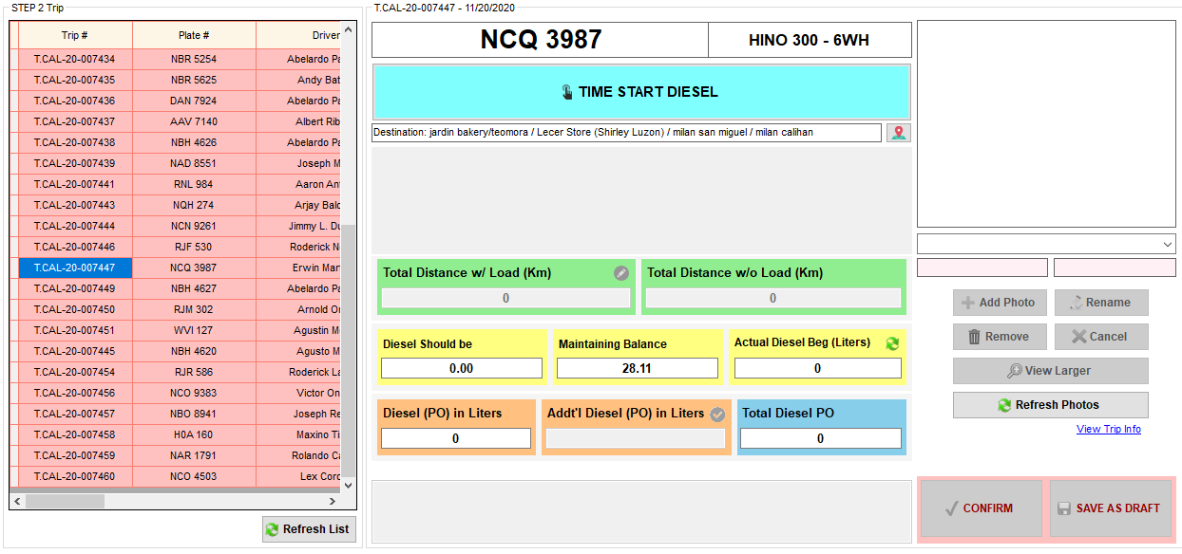

Click this button to view the standard distance

* To check if the standard distance is already set in the database, click the GPS POI button beside the destination label.

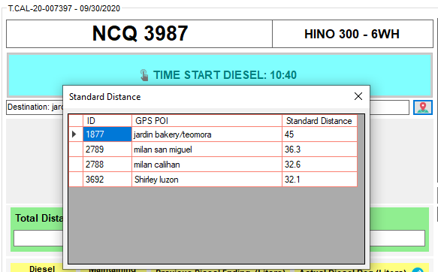

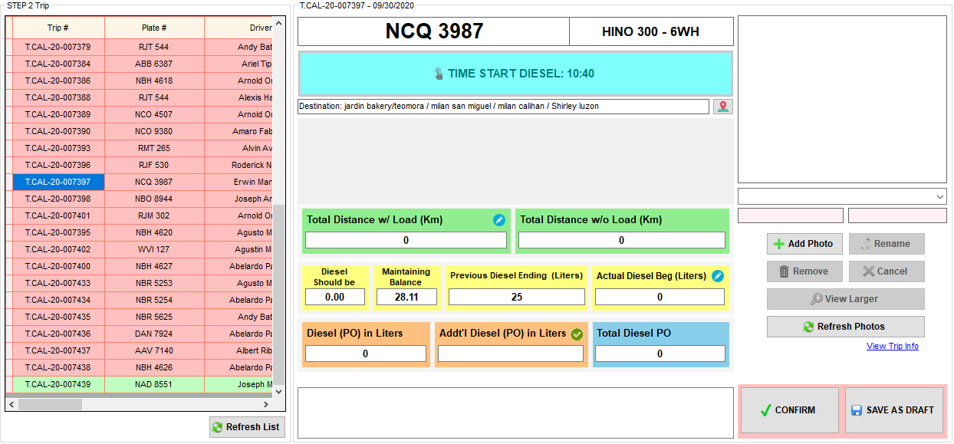

Click this icon to compute for distance

1. Click the icon beside the Total Distance w/ Load (Km)

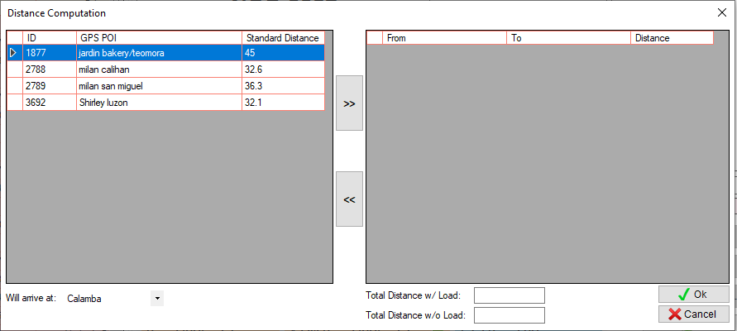

2. Select the first destination

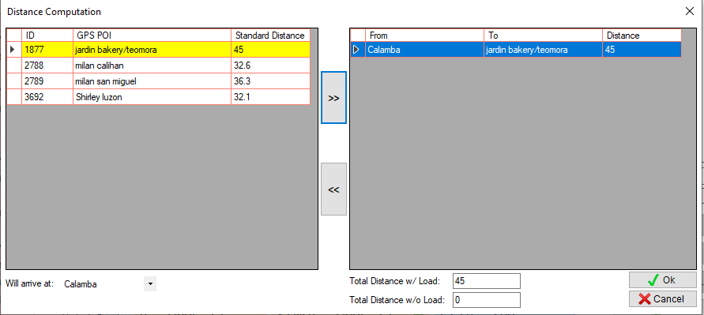

3. Click this button

4. Automatically shows the distance from warehouse to the first destination

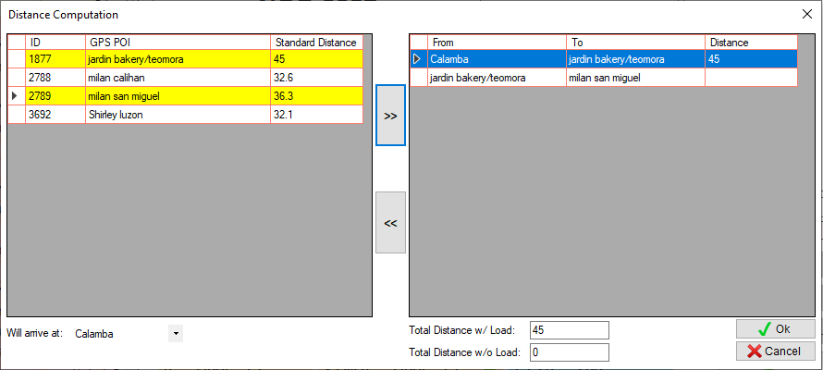

5. Select the next destination

6. Click this button

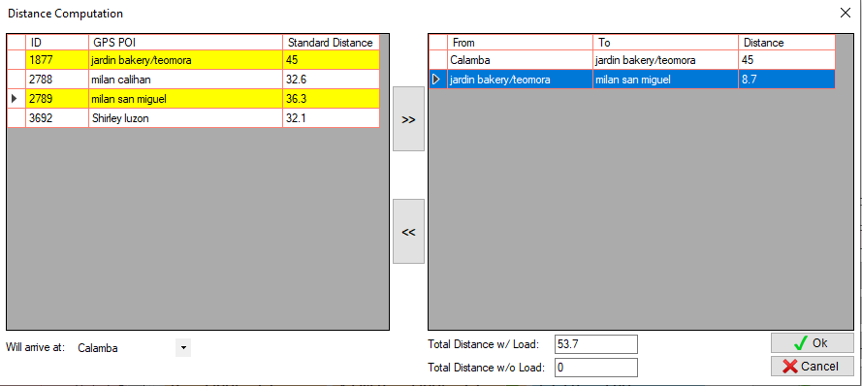

7. Input distance from jardin bakery to milan san miguel

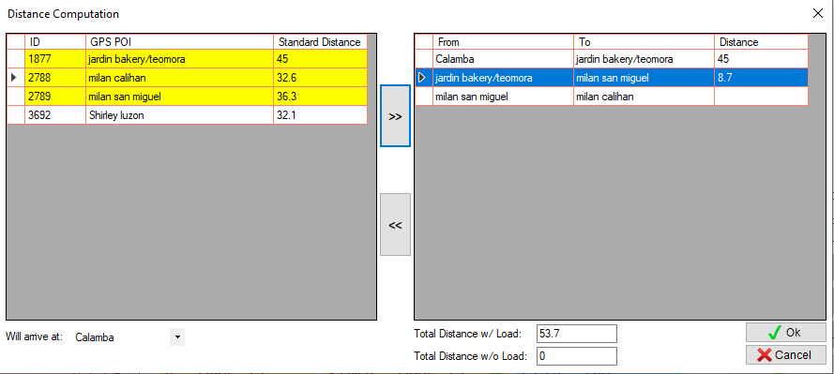

8. Select the next destination

9. Click this button

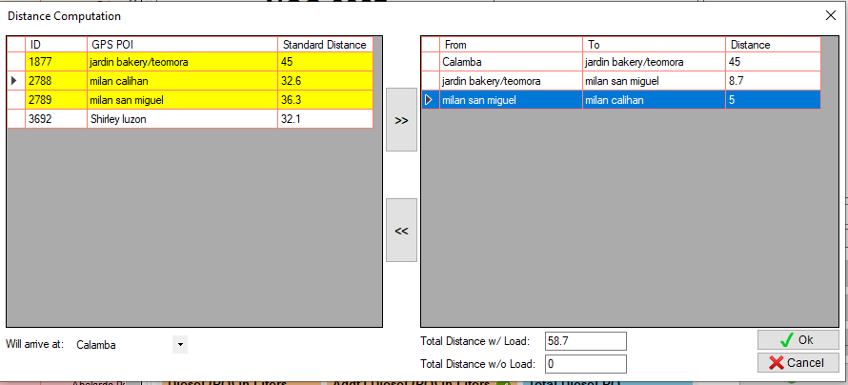

10. Input distance from milan san miguel to milan calihan

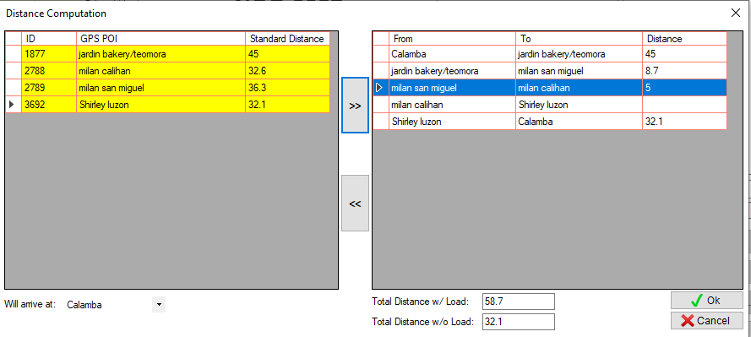

11. Select the next destination

12. Click this button

13. Last destination to warehouse will automatically added.

14. Automatically shows the distance from last destination to warehouse

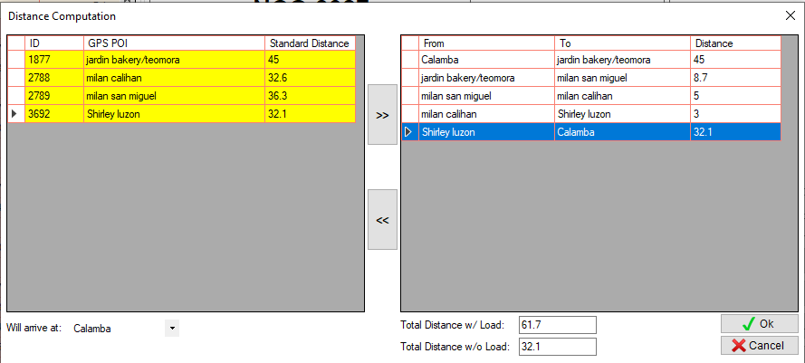

15. Input distance from milan calihan to Shirley luzon

16. Automatically computes the Total Distance w/ Load and the Total Distance w/o Load

17. Click OK button.

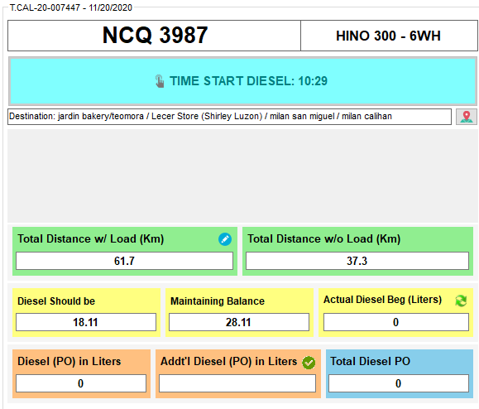

# Trip Dispatching. (Step 3)

* Since ang gagamitin na plate# for customer truck and trucking truck, mayroon ng filter para mas madali makita.

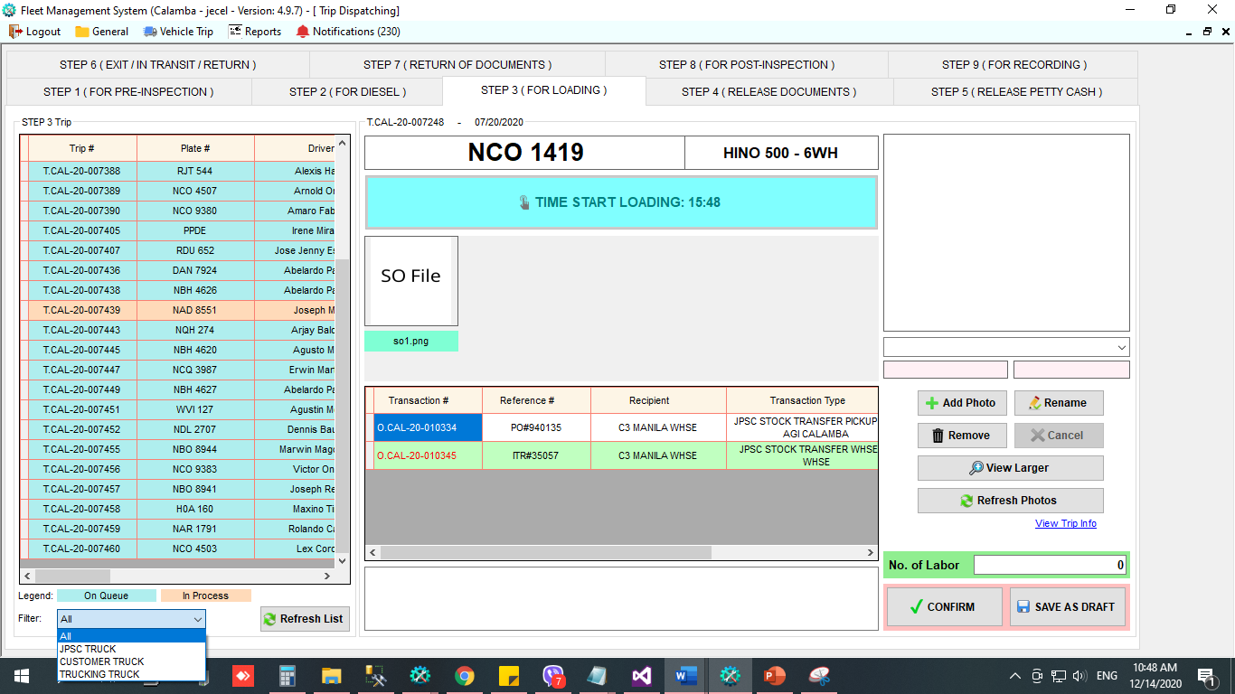

# Trip Dispatching. (Step 4)

* Nadagdag sa column ang GPS POI name
* Since ang gagamitin na plate# for customer truck and trucking truck, mayroon ng filter para mas madali makita.

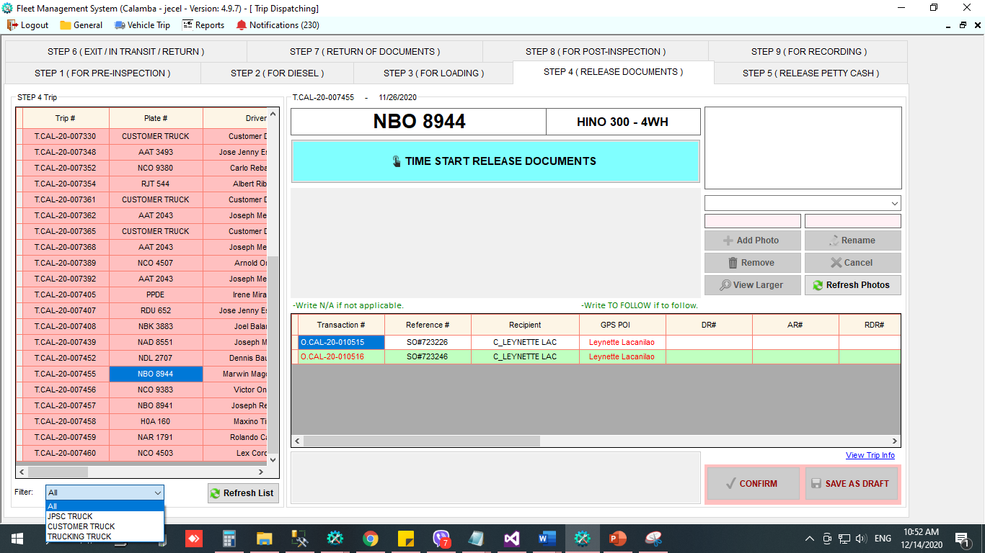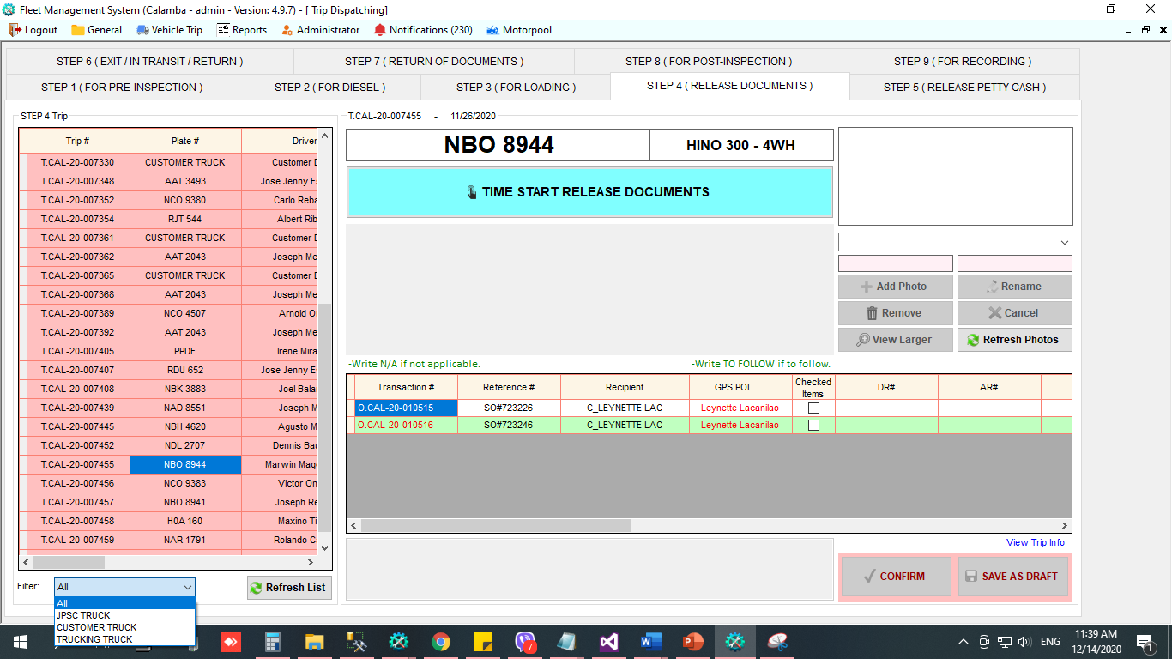

* 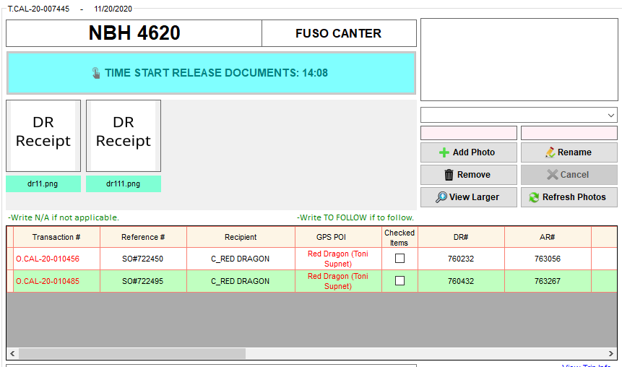Bago mag confirm make sure na tama din ang items and quantity sa create order.

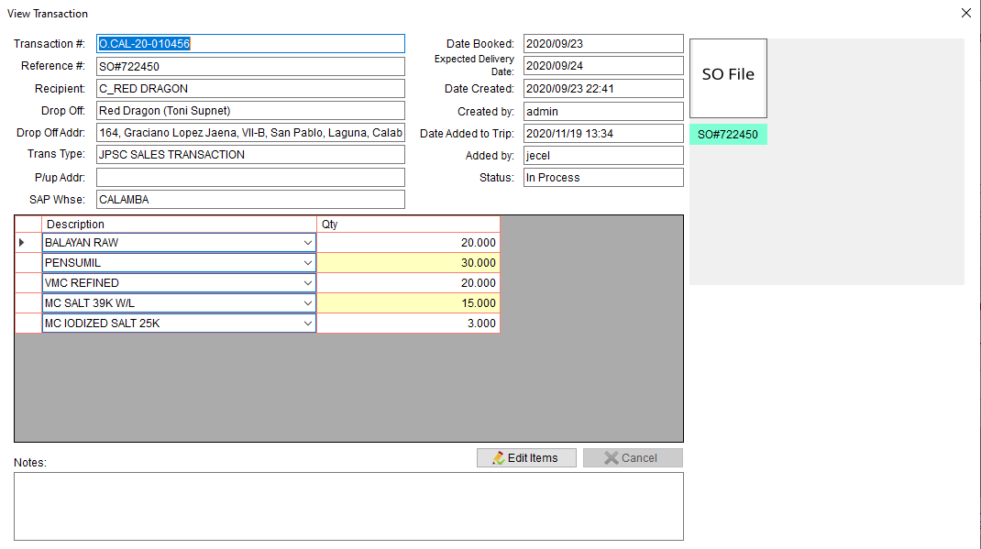

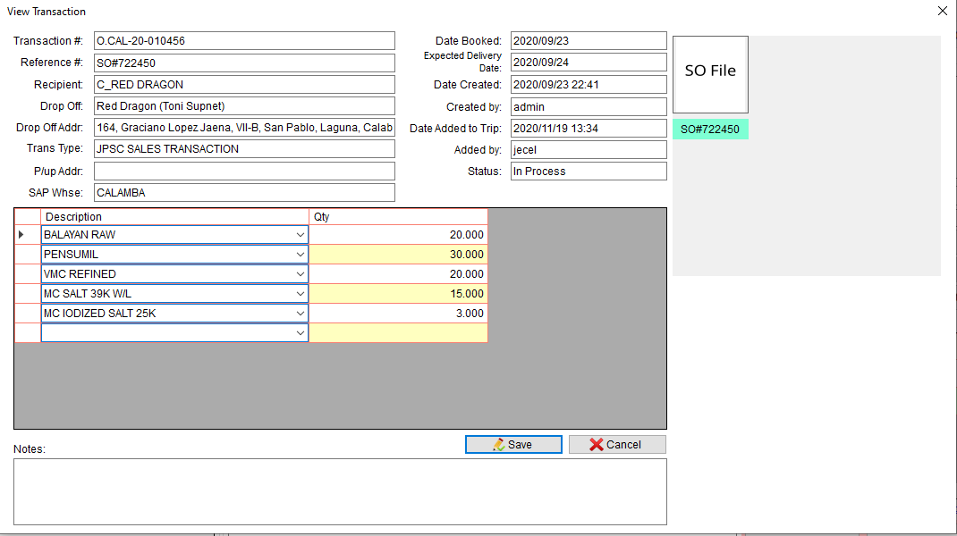

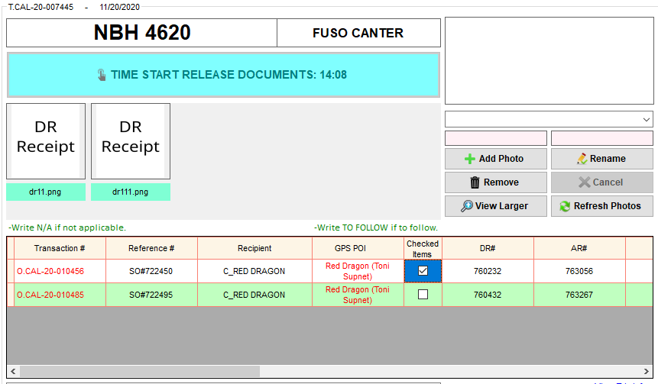

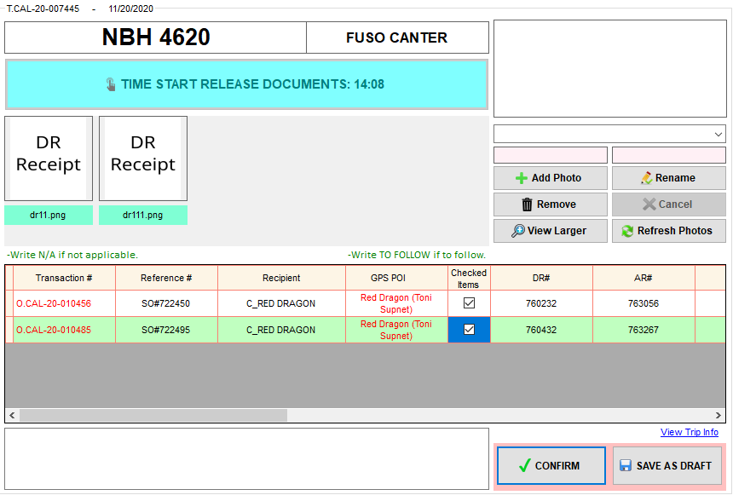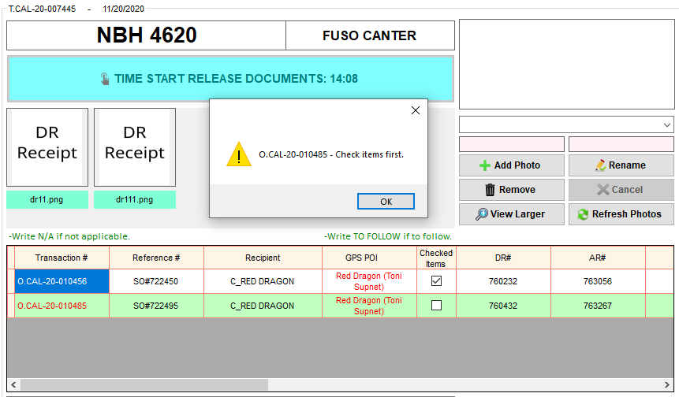

# Trip Dispatching. (Step 7)

* Pwede din mag filter kung JPSC TRUCK, CUSTOMER TRUCK, TRUCKING TRUCK

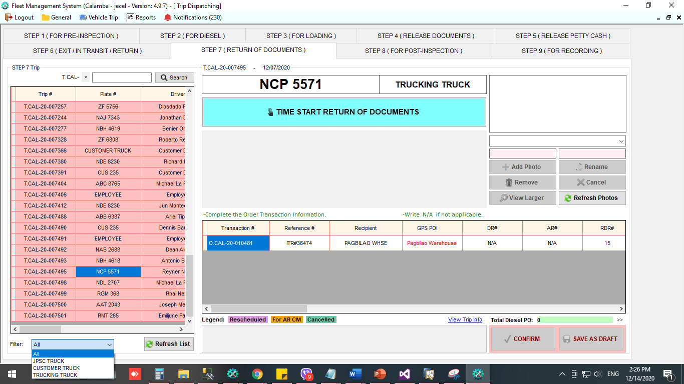

* Pinaghiwalay na ang For AR Credit Memo at Cancelled
* Additional column na BL#

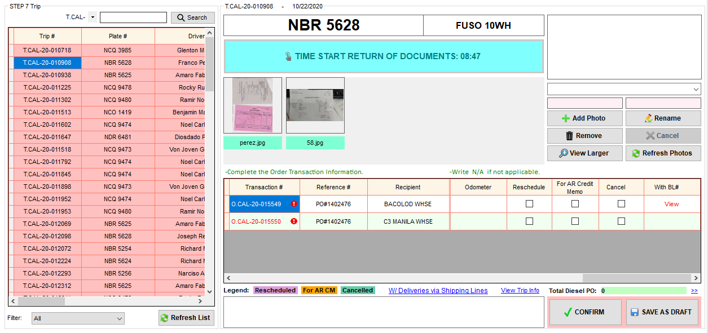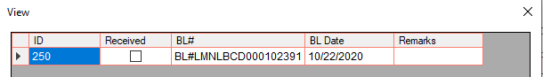

# Trip Dispatching. (Step 9)

* 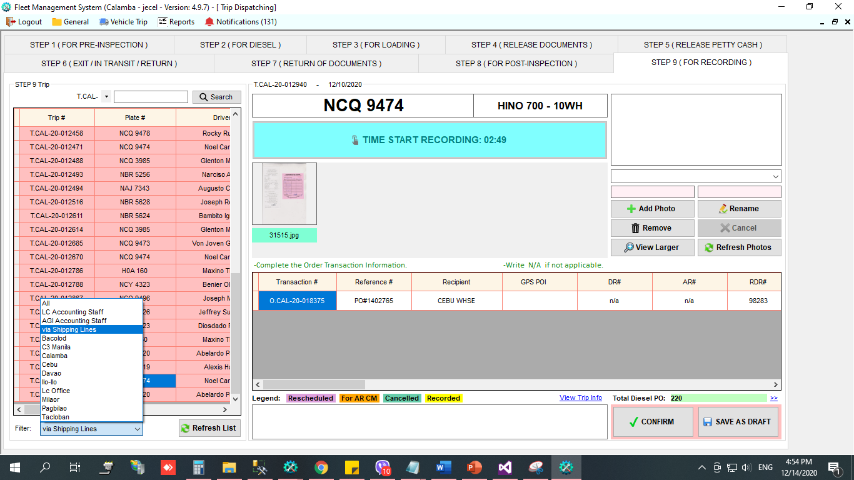Filter ng mga trip na dumaan sa Shipping Lines – si LC Accounting ang mag rerecord

# Temporary POI

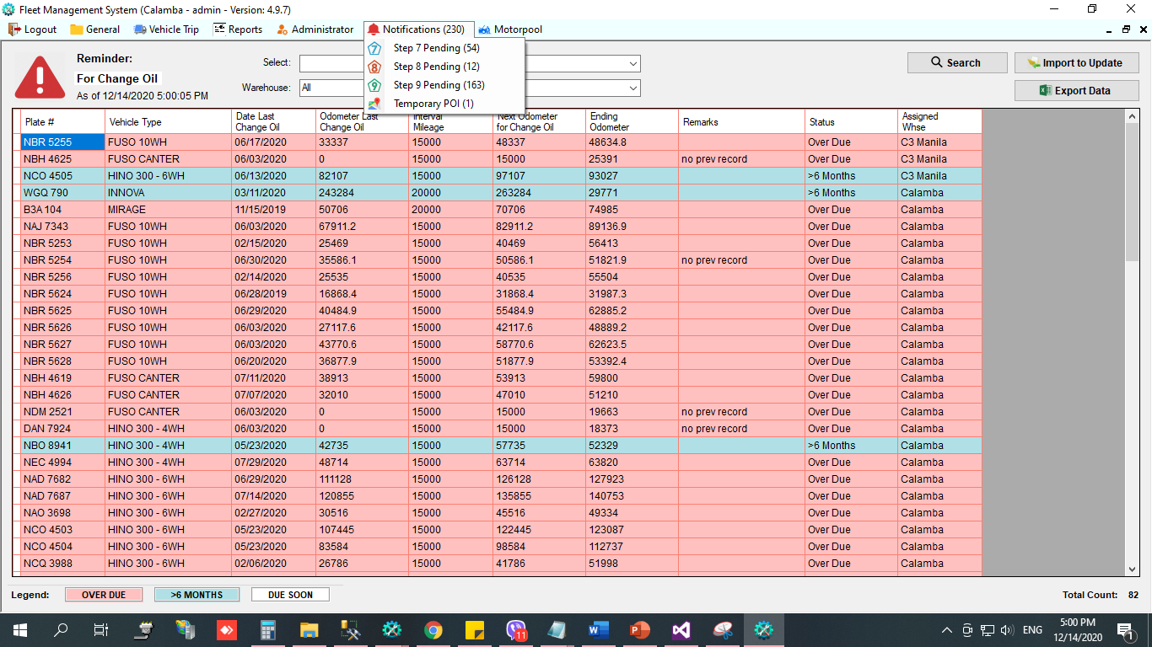

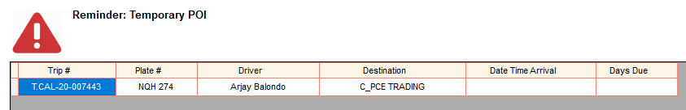

* To update the POI (for Logistics Staff only)

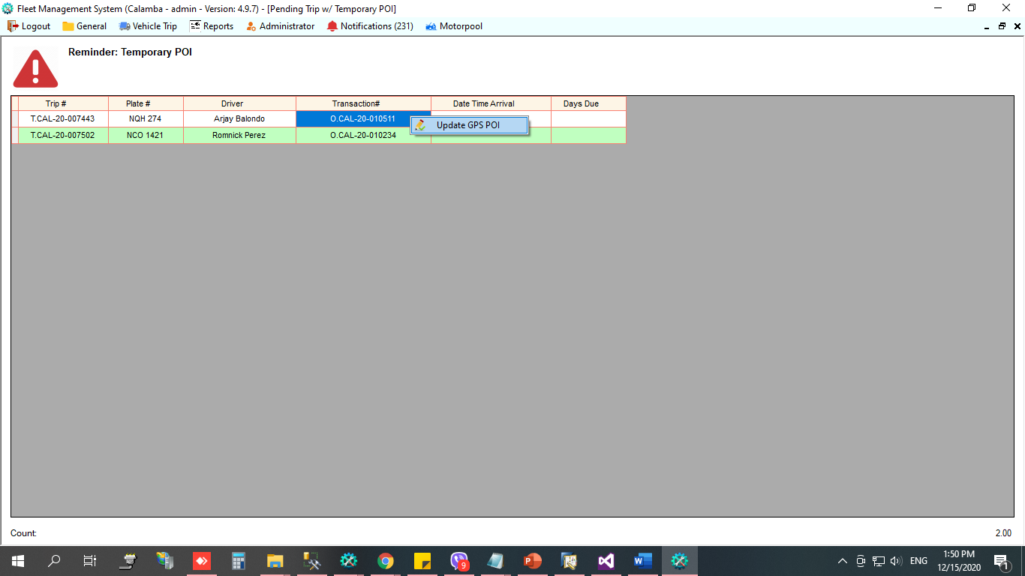

1. Right click the transaction#
2. Then, select Update GPS POI

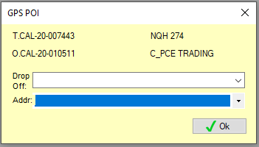

1. Update the drop off point and address
2. 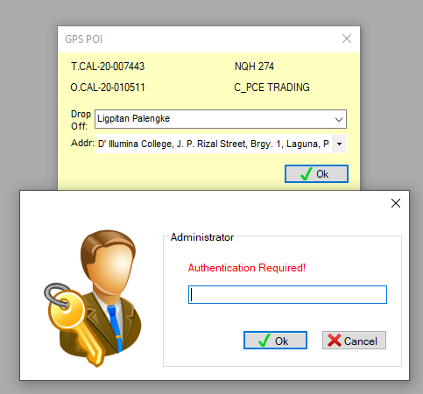Then, click Ok button
3. Input password.
4. 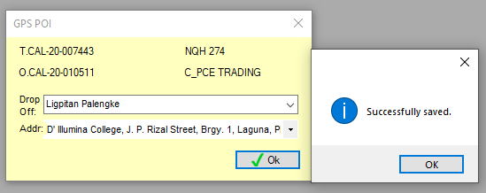Then, click Ok button.

# Motorpool Inspection Status

* Pwede makita ang status ng mga truck sa Motorpool inspection

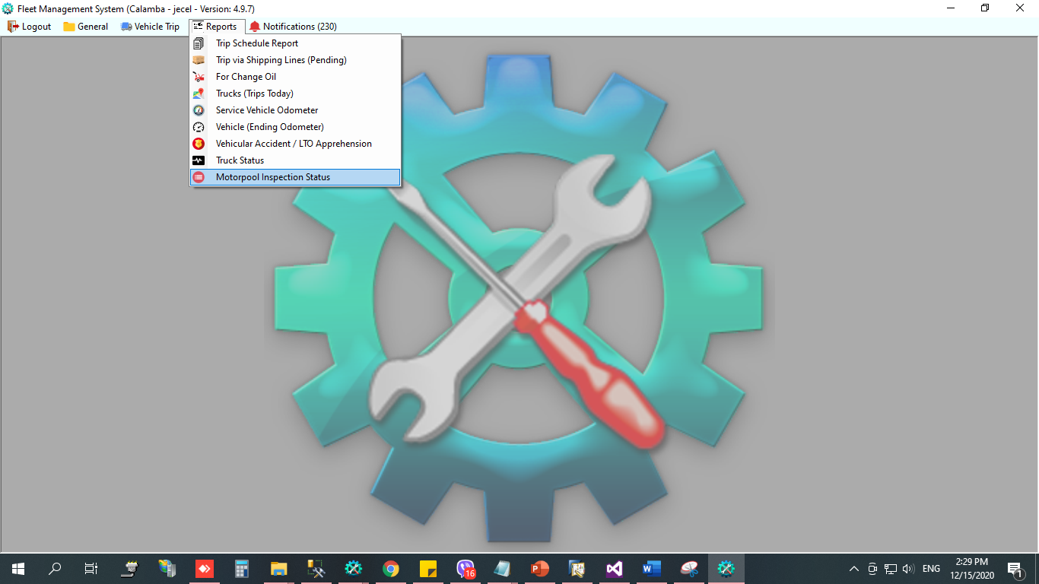

1. 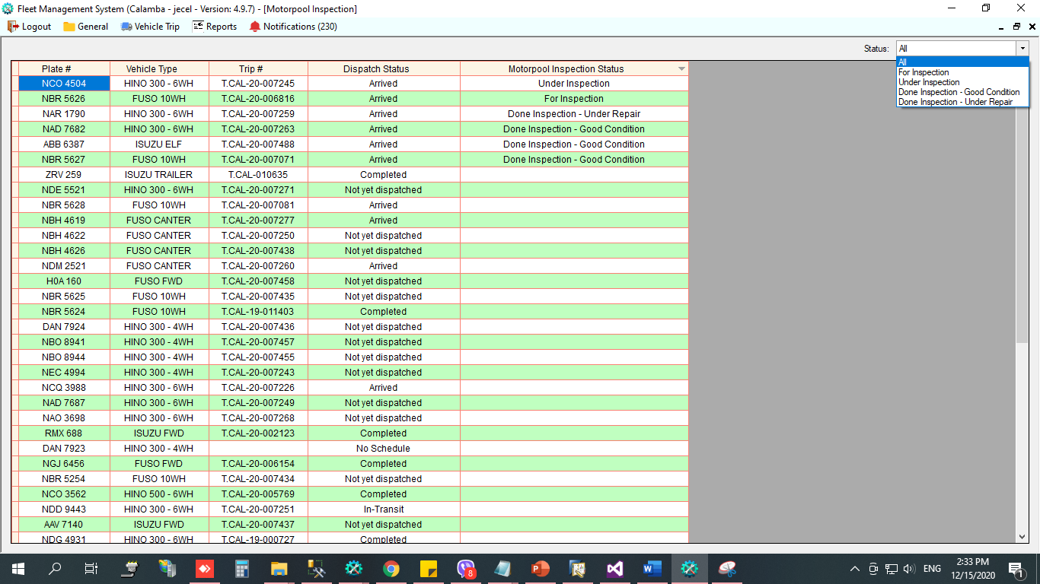In Reports menu, select Motorpool Inspection Status

Flow

